- List employees with their department name & location
select e.eno,e.ename,d.dname,d.dloc
from emp e,dept d
where e.deptno=d.deptno;
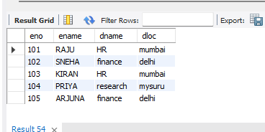
- Employees who are not assigned to any project ,Project-wise headcount
delete from assignes_to
where eno 105;
select eno,ename
from emp
where not exists (select 1 from assignes_to
where emp.eno=assignes_to.eno);
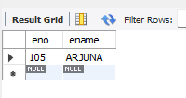
3.Department-wise average & max salary
select dept.dname,dept.deptno,max(emp.sal),
avg(emp.sal)
from emp,dept
where emp.deptno=dept.deptno
group by dept.dname,dept.deptno;
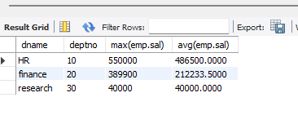
- Total incentives earned by each employee (lifetime)
select eno,sum(inc_amount)
from incentives
group by eno;
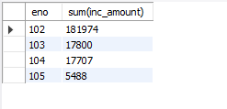
- Employees working on a given project (project name :orion)
select eno ,ename
from emp where eno in (select eno from assignes_to where pno in(select pno from project where pname="orion"));
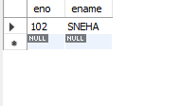
- Departments with no employees
select deptno,dname from dept where not exists (select 1 from emp where dept.deptno =emp.deptno);
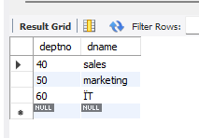
7.Managers and their direct report counts (MGR_NO references EMPNO)
select m.eno as "mgr no", m.ename as "mgr name",count(e.eno) as "report counts" from emp m,emp e where m.eno=e.mgr_no group by m.eno,m.ename;
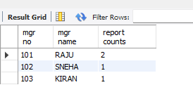
- Employees assigned to more than one project.
select emp.eno,emp.ename
from emp,project,assignes_to where project.pno=assignes_to.pno
and emp.eno=assignes_to.eno
group by emp.eno,emp.ename
having count(project.pno)>1;
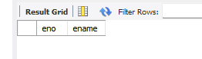
- Display those employees who are working in the same department where his manager is
working.
select e.eno,e.ename,e.deptno,m.ename as "manager name"
from emp e
join emp m on e.mgr_no=m.eno
where e.deptno=m.deptno;
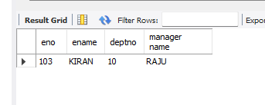
- Display those managers name whose salary is more than average salary of his employee.
select m.eno,m.ename,m.sal
from emp m
join emp e on m.eno=e.mgr_no
group by m.eno,m.ename,m.sal
having avg(e.sal)<m.sal;
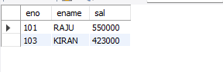

- Find the name of the second top level managers of each department.
select distinct d.dname as dept,e.ename as "second top manager"
from emp e join emp m on e.mgr_no=m.eno join dept d on e.deptno=d.deptno where m.mgr_no is null;
